Functional Electrical Stimulation
Irina TURTUREANU
Radu BREAHNĂ
State University of Medicine and Pharmacy “Nicolae Testemitanu” Moldova
radu_breahna@yahoo.com
State University of Medicine and Pharmacy “Nicolae Testemitanu” Moldova
Abstract — This paper is focused on Functional Electrical Stimulation, a technique that uses electrical stimuli to reestablish the normal activity of organs deprived of nervous control. The concept itself is described along with information about its origin, history, current application and future development. The paper also presents a FES device, developed by the authors, and the experimental results of its testing.
Index Terms — Arduino, Biomedical electrodes, Brain computer interfaces, Electrical stimulation, Microcontrollers.

INTRODUCTION
Functional Electrical Stimulation (FES) is a technique that uses small electrical pulses applied to paralyzed muscles to restore or improve their function. It is primarily used to restore function in people with disabilities caused by spinal cord injury (SCI), head injury, stroke and other neurological disorders. FES can also be referred to as Neuromuscular Electrical Stimulation (NMES)[1].
FES was initially named Functional Electrotherapy by Wladimir Liberson [2] and it wasn't until 1967 that the term Functional Electrical Stimulation was coined by Moe and Post and used in a patent entitled, "Electrical stimulation of muscle deprived of nervous control with a view of providing muscular contraction and producing a functionally useful moment". The first commercially available FES devices treated foot drop by stimulating the peroneal nerve during gait. In this case, a switch, located in the heel end of a user's shoe, would activate a stimulator worn by the user (fig. 1).
Fig.1. The Odstock Dropped foot stimulator

Lieberson announced a considerable improvement in the movement of hemiplegic patients who have tested this type of neuroprosthesis. The idea became the basis for research programs at such facilities as (University Rehabilitation Institute – Ljubljana, Rancho Los Amigos, Downey, USA, etc.) [3,4]. In consequence many FES devices were designed and tested; nonetheless few made it into clinics for the treatment of patients.

IMPLEMENTATION
Functional electrical stimulation coordinates the activation of the groups of muscles in such a way that the resulting movement of the inferior or superior limbs will correspond to the normal, voluntary one.
The patients who can benefit from treatments based on functional electrical stimulation are:
- Patients with a stroke, or cerebrovascular accident (the first 6 months are decisive in recovery)
- Patients with multiple sclerosis (improves the quality of movements)
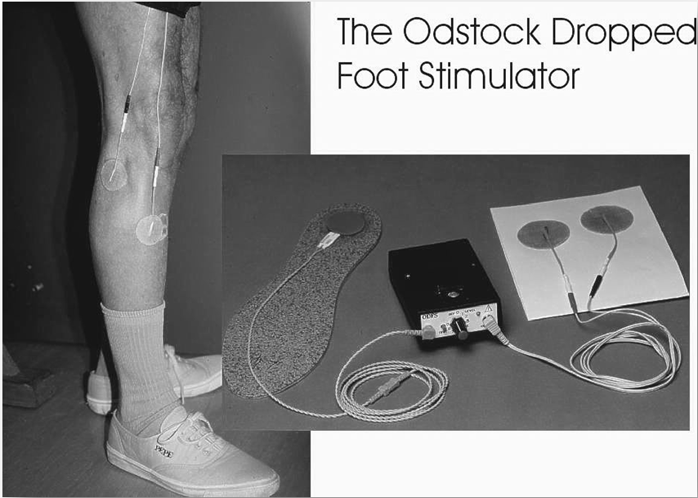
- Patients with Parkinson’s disease (the quality of walking is improved significantly)
- Paralyzed patients (sustaining exercises)[5,6]
Research in the neural-prosthesis field resulted in the following applications:
- Neural-prosthesis controlling urination and defecation[8,9];
- Neural-prosthesis implanted in arms intended for controlling the grabbing function[10];
- Neural-prosthesis that help paraplegic patients transfer from wheel-chair on the toilet and from chair to bed[11,12];
- Neural-prosthesis for walking[13];
An implanted system called “Free Hand” [10] considerably improves the functional abilities of a tetraplegic patient’s hand, with lesions of the spinal cord at the C6-C7 level.
All around the world there are a total of 150 patients that benefit from using this implanted system. Thought, few of the integrated neural-prostheses are used in typical clinical treatment.

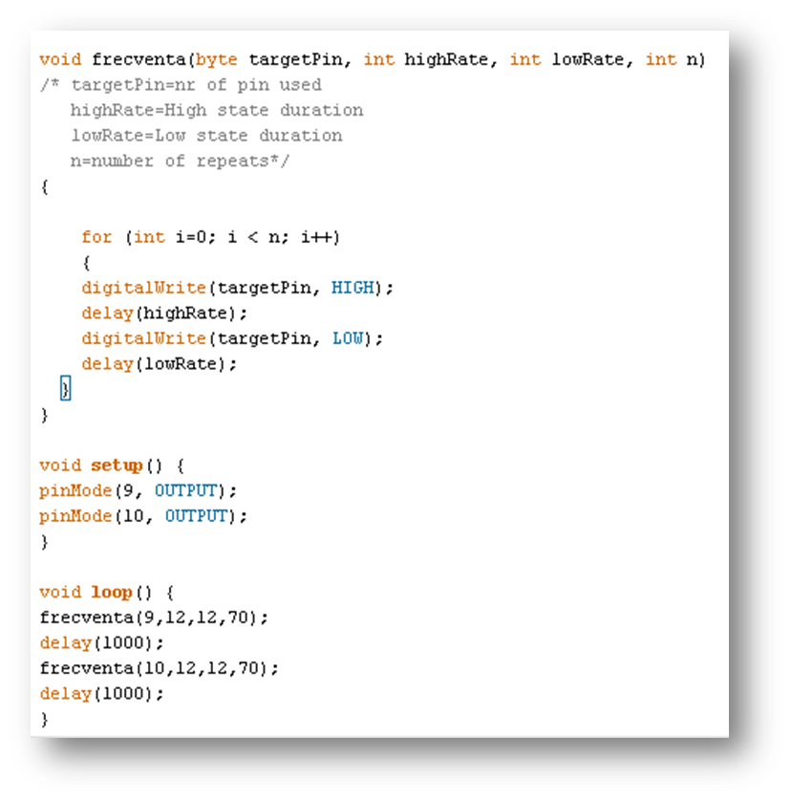
FUNCTIONAL ELECTRICAL STIMULATION
Electrical stimulation is done using implanted electrodes or electrodes placed on the surface of the skin.
Surface electrodes are easier to use, however they cause problems related to electric conductivity and muscle selection and isolation. They also move with the skin on which they are placed and can become inefficient during functional movement.
Implanted electrodes are much more difficult to set up, they can cause complications such as infection. However, when placed correctly they allow precise control over the muscles and nerves that need to receive stimulation. Furthermore, due to the advancement in microelectronics implanted electrodes have become more and more miniaturized [7].
Stimulation is performed with electrical pulses of a square waveform. When using surface electrodes on muscles with an intact motor neuron, the pulse parameters are: 20Hz-40Hz frequency, pulse duration between 5 µs and 350 µs and a current of 20 mA - 100 mA [6]. In the case of implanted electrodes, contraction can be achieved with a 20 mA current and pulse duration of 200 µs. Muscles deprived of innervation require a pulse duration around 150 ms for contraction.
The objectives of our group were to build a working model of a FES device using the methods and materials available today and demonstrate the efficiency of functional electrical stimulation when it comes to improving control over paralyzed muscles. Our secondary goal is to encourage research in this field by illustrating how accessible and flexible this method is, and what potential benefits it may have in the future.

DESIGN
FES devices consist mainly of two parts: a stimulator and a microcontroller. The stimulator is the source of electrical impulses and the controller – a way of programing various algorithms for contraction and relaxation.
Our stimulator was made up of 4 simple mosfet circuits equipped with a voltage regulator, a potentiometer (connected as a voltage divider) and signal LEDs for each of the 4 channels. The circuit was assembled on a breadboard.
The microcontroller we used is called Arduino, a single-board microcontroller designed to make the process of using electronics in multidisciplinary projects more accessible. Arduino is a descendant of the open-source Wiring platform and is programmed using a Wiring-based language (syntax and libraries), similar to C++ with some slight simplifications and modifications, and a Processing-based integrated development environment (fig. 2)
The implantable electrodes used in our experiments were improvised from insulated copper wire and stainless steel needles.

Fig.2. Example of one of the programs used

TESTING
Experiments were conducted on frog hind legs which required the use of special parameters adjusted for frog muscle fibers. These parameters were obtained from a study at Northwestern University USA where students determined the relationship between different types of electrical stimuli and frog muscle response (fig. 4). Based on their results, our FES system used a signal of 41.6 Hz and 50% duty cycle and a voltage that varied from 3V to 6V depending on the case. This combination showed an acceptable degree of contraction and movement.
In every experiment we used paralyzed frogs with no motor or sensory functions of the lower limbs.

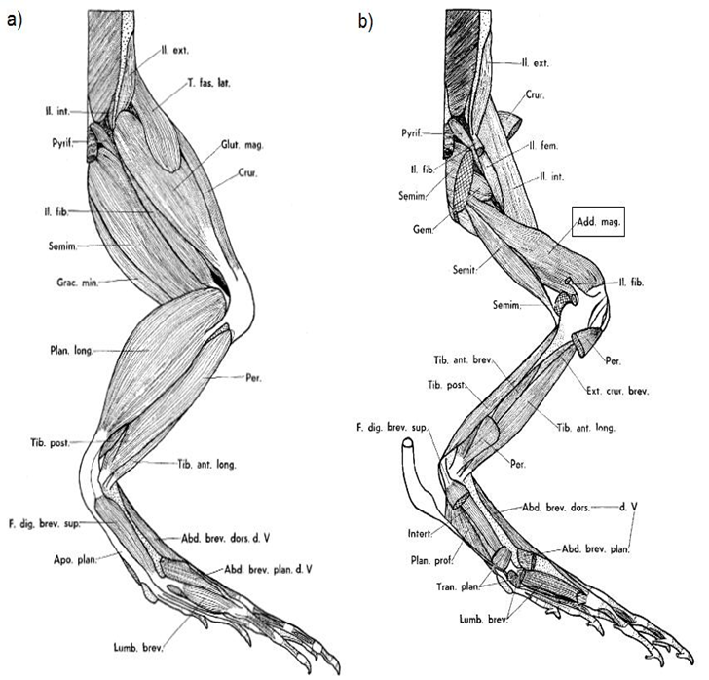
Fig.3. Frog hind leg anatomy
Electrodes were inserted in individual muscles or muscle groups of the thigh and leg (fig. 3). Our results were recorded in video format and can be found online [16]

In our first experiment we began by alternately stimulating only one muscle and obtained a movement of flexion and relaxation, we also showed that the duration of each phase of this cycle can be modified via changes in the controller’s program.
In the second experiment we stimulated two muscle groups that gave us a movement of flexion and extension in the ankle joint.
In the final third experiment we aimed to obtain knee flexion which proved to be difficult due to the proximity of muscles performing other functions to the muscles responsible for flexion. By inserting electrodes in the muscle group containing the flexors, other muscles were triggered resulting in movement not required by the experiment. A simple workaround was found by “electrically isolating” the needed muscles from a group. One electrode was inserted in the thigh while the other was placed below the knee joint, thus the shortest path for our stimuli was from the flexor muscles in the posterior group of the thigh to their insertion point below the knee. The result was satisfactory.
An additional experiment was attempted using all 4 channels of our stimulator to control 4 muscles at once. However our stimulator proved to be inappropriate for such a task as it lacked stimulus isolation.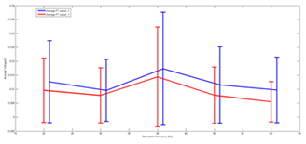
Fig. 4. Force transducer reading for different stimulus frequency levels

FUTURE DEVELOPMENT
The future of SEF technology is within the concept of the Brain-Computer Interface (BCI)(fig. 2). Integrating these two would allow muscles to receive stimuli directly from the brain and not from a pre-programed device. This essentially solves the problem of damaged nerve fibers as the information is transported to the target cell via synthetic pathways. BCI works by reading brain activity and using that data to generate electrical impulses that perform functional electrical stimulation. Currently we know of at least two major breakthroughs in this field that we came to know of through two experiments. One from 2008(fig. 3) in which a team from the Department of Neurobiology in Pittsburgh, Pennsylvania USA allowed a monkey to feed herself using a robotic arm controlled through a brain-computer interface[14]. The other experiment from 2012 (fig. 4) comes from Northwestern University where a monkey was able to successfully perform a grasping task with a paralyzed arm with the aid of a FES system controlled through BCI[15].

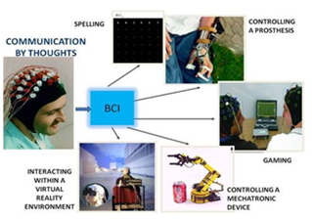
Fig.5. The Brain-Computer Interface
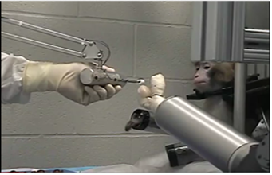

Fig.6. Cortical control of a prosthetic arm for self-feeding

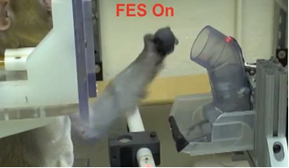

Fig.7. Restoration of grasp following paralysis through brain-controlled stimulation of muscles

CONCLUSION
In conclusion we believe that FES is an efficient technique when treating paralysis and other forms of damaged innervation. FES devices are easy to manufacture develop and test. And most importantly functional electrical stimulation must be developed and coupled with the brain-computer interface in order for it to reach its maximum efficiency.
REFERENCES
[1] M. Claudia et al.,(2000), Artificial Grasping System for the Paralyzed Hand, International Society for Artificial Organs, Vol 24 No.3 pp:185-188
[2] Liberson W, Holmquest H, Scott M. (1961). Functional electrotherapy: Stimulation of the common peroneal nerve synchronised with the swing phase of gait of hemiplegic subjects. Arch Phys Med Rehabil 42. 202-205.
[3] Malezic M, Trnkoczy A, Rebersek S, et al. (1978). Advanced cutaneous electrical stimulators for paretic patients personal use. Advances in External Control of Human Extremities VI, Dubrovnik, Yugoslavia, 150-167.
[4] Waters R, Bowman B, et al. (1981). Treatment of hemiplegic upper extremity using electrical stimulation and biofeedback training. Advances in External Control of Human Extremities VII, Dubrovnik, Yugoslavia.
[5] Rushton DN (1997). Functional Electrical Stimulation, Physiological Measurement 18(4), 1997, 241-275.
[6] Taylor PN, Burridge JH, Dunkerley AL, Lamb A, Wood DE, Norton JA, Swain ID. (1999) Patient's Perceptions of the Odstock Dropped Foot Stimulator (ODFS). Clin. Rehabil 13: 333-340.
[7] Loeb GE, Peck RA, Moore WH, Hood K (2001). BION system for distributed neural prosthetic interfaces, Medical Engineering&Physics 23: 9-18.
[8] Rijkhoff NJM, Wijkstra H, van Kerrebroeck PEV, Debruyne FMJ (1997). Urinary bladder control by electrical stimulation: Review of electrical stimulation techniques in spinal cord injury. Neurourol Urodyn 16: 39-53.
[9] Riedy L, Bruninga K, Walter J, Keshavarzian A (1997). Direct electrical stimulation for constipation treatment sfter spinal cord injury. Proc. 19th Int Conf IEEE/EMBS, Chicago, 1799-1802.
[10] Taylor P., Esnouf J., Hobby J (2000). Clinical Experience of the NeuroControl Freehand System, Proc 5th IFESS Conference, Aalborg, Denmark, June 2000.
[11] Poboroniuc, M.S., Fuhr, T., Riener, R., Donaldson, N. (2002). Closed-Loop Control for FES-Supported Standing Up and Sitting Down. Proc. 7th Conf. of the IFESS; Ljubljana, Slovenia, pp. 307-309.
[12] Poboroniuc, M.S., Fuhr, T., Wood, D., Riener, R., Donaldson, N. (2002): Functional FES supported standing in paraplegia: Current Research and Perspectives, MASCIP Conference 2002, Warwick, UK, November 14th,
[13] T. Fuhr, J. Quintern, R. Riener, G. Schmidt (2001) "Walk! - Experiments with a Cooperative Neuroprosthetic System for the Restoration of Gait", Proc. 6th Conf. Of the IFESS, Cleveland, OH, USA, pp. 1-3.
[14]Velliste..Schwartz “Cortical control of a prosthetic arm for self-feeding”, Nature 453, 1098-1101 (19 June 2008)
[15]C. Ethier.. L. E. Miller “Restoration of grasp following paralysis through brain-controlled stimulation of muscles”, Nature 485, 368–371 (17 May 2012)
[16] Arduino Fes 2012, “Arduino FES-Controlling paralyzed limbs”, video, YouTube, 6 August, viewed 27 January 2013, http://www.youtube.com/watch?v=qjFm8krKsCg

